Parte superior do formulário

Pergunta 1: **Incorreto**

An IT Engineer needs to create a Virtual Machine in Azure. Currently, the IT Engineer has a Windows desktop along with the Azure Command Line Interface (CLI). Which of the following would allow the IT engineer to use the Azure Command Line Interface? Choose 2 answers from the options given below.

* 

**A. Powershell**

**(Correto)**

* 

**B. File and Print Explorer**

* 

**C. Command Prompt**

**(Correto)**

* 

**D. Control Panel**

**Explicação**

**Answer: A and C**

You can launch the Azure command-line tool from the command prompt as shown below.



Or you could also launch it from PowerShell as shown below.

**Options B and D are incorrect** because you can’t launch Azure Command-Line from any of these options.

For more information on Azure Command Line Interface, please visit the below URL-

<https://docs.microsoft.com/en-us/cli/azure/get-started-with-azure-cli?view=azure-cli-latest>

Parte inferior do formulário

Parte superior do formulário

Pergunta 2: **Incorreto**

A customer is planning to create several Azure Free Accounts. Can a customer have an allowance of a maximum of 10 Azure Free Accounts?

* 

**A. Yes**

**(Incorreto)**

* 

**B. No**

**(Correto)**

**Explicação**

**Answer: B**

A customer can only have one Azure Free Account. This is also given in the Microsoft documentation.



For more information on the Azure Free Account, please visit the below URL-

<https://azure.microsoft.com/en-us/free/free-account-faq/>

Parte inferior do formulário

Parte superior do formulário

Pergunta 3: **Incorreto**

Your company is planning to host resources in Azure. Can an administrator give access to partners who do not have an Azure AD account to access resources in Azure?

* 

**A. Yes**

**(Correto)**

* 

**B. No**

**(Incorreto)**

**Explicação**

**Answer: A**

Azure has other capabilities in place that can allow other partners to access Azure-based resources. For example, Azure has the feature of Azure AD Business to Business collaboration where the partners don’t have to be defined in Azure.

The Microsoft documentation mentions the following on Azure B2B.

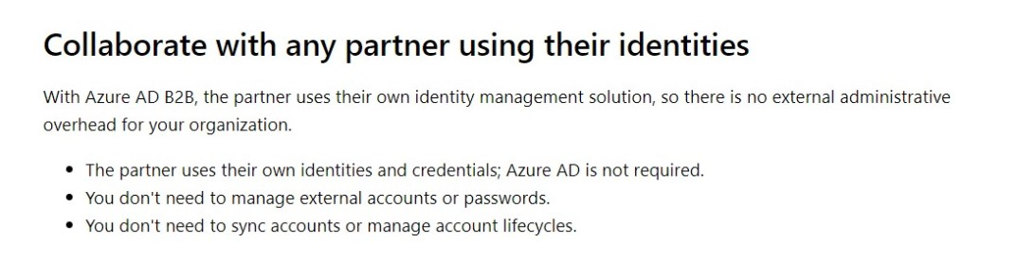

For more information on Azure B2B, please visit the below URL-

<https://docs.microsoft.com/en-us/azure/active-directory/b2b/what-is-b2b>

Parte inferior do formulário

Parte superior do formulário

Pergunta 4: **Incorreto**

Your organization is looking for a physical migration service that helps to transfer 70 TB of files from an on-premise data center to Azure in a quick, inexpensive, and reliable way. Which of the following services will you select for this task?

* 

**A. Azure Batch**

**(Incorreto)**

* 

**B. Azure ExpressRoute**

* 

**C. Azure Data Box**

**(Correto)**

* 

**D. Azure Migrate**

**Explicação**

**Answer : C**

The organization is looking for a physical data transfer method.

* **Option A is Incorrect:**Azure Batch is not used for data transfer. Azure Batch runs large-scale applications efficiently in the cloud.
* **Option B is Incorrect:** Azure ExpressRoute is a service that enables you to create private connections between Azure datacenters and on-premises infrastructure or in a colocation environment.
* **Option C is Correct:**Azure Data Box ships a storage device to your data center that has a maximum usable storage capacity of 80 TB. So, Azure Data Box helps to move large amounts of data to Azure with little or no impact on the network.
* **Option D is Incorrect:**Azure Migrate is an infrastructure Migration service.

**References:**

* [Microsoft Azure Data Box overview | Microsoft Docs](https://docs.microsoft.com/en-us/azure/databox/data-box-overview)
* <https://azure.microsoft.com/en-us/services/expressroute/#overview>

Parte inferior do formulário

Parte superior do formulário

Pergunta 5: **Incorreto**

Your company has implemented Work From Home. As per company policies, your employees should be able to sign in to the Azure portal only when they are using the company-provided devices (which are registered in Azure Active Directory) from their base location (which is India).

You want to block the sign-in attempt to Azure Portal when either of the condition fails. What should you configure to achieve this?

* 

**A. Azure AD Device management**

* 

**B. Azure AD Privileged Identity Management (PIM)**

**(Incorreto)**

* 

**C. Azure RBAC**

* 

**D. Conditional Access**

**(Correto)**

**Explicação**

**Answer: D**

According to the question, we need to block sign-in attempts IF any specific condition is met.

IF the sign-in attempt is from an unexpected Location/device

THEN Block the access.

* **Option A is Incorrect :**Azure AD Device management helps register our devices to azure. Hence, it can not help to block the sign-in from untrusted locations.
* **Option B is Incorrect:**Privileged Identity Management (PIM) enables you to manage, control, and monitor access to important resources in your organization. These resources include resources in Azure AD, Azure & M365.
* **Option C is Incorrect:**Azure RBAC helps us to give fine access control to our users, but it can not identify signals (Unexpected device/ location) and allow or deny the sign-in attempts.
* **Option D is Correct:**Conditional Access checks the conditional statement (also called an If-Then Statement), which helps you to allow/deny/require MFA to a sign-in attempt based on the signals(like location, type of device, etc).

**Reference:**

* [What is Conditional Access in Azure Active Directory? - Microsoft Entra | Microsoft Docs](https://docs.microsoft.com/en-us/azure/active-directory/conditional-access/overview#common-signals)

Parte inferior do formulário

Parte superior do formulário

Pergunta 6: **Incorreto**

Azure Advisor dashboard displays personalized recommendations to optimize your Azure deployments. Which of the following options are not included in the Azure Advisor recommendations?

* 

**A. Reliability**

* 

**B. Performance**

**(Incorreto)**

* 

**C. Predictability**

**(Correto)**

* 

**D. Cost**

**Explicação**

**Answer: C**

Azure Advisor gives proactive, actionable, and personalized best practices recommendations to help you improve your azure cloud deployments.

* **Option A is Incorrect :** Azure Advisor gives recommendations on Reliability to ensure and improve the continuity of your business-critical applications.
* **Option B is incorrect :**Azure Advisor gives a recommendation on Performance to improve the speed of your applications.
* **Option C is Correct:**Azure Advisor does not give a recommendation on Predictability.
* **Option D is incorrect**: Azure Advisor gives the recommendation to optimize and reduce your overall Azure spending.

**Reference:**

* [Introduction to Azure Advisor - Azure Advisor | Microsoft Docs](https://docs.microsoft.com/en-us/azure/advisor/advisor-overview)

Parte inferior do formulário

Parte superior do formulário

Pergunta 7: **Correto**

A company is planning to create several SQL Databases in Azure. They would be using the Azure SQL Database service. Which of the following is the right category to which the Azure SQL Database service belongs to?

* 

**A.**

**Infrastructure as a service (IaaS)**

* 

**B.**

**Platform as a service (PaaS)**

**(Correto)**

* 

**C.**

**Software as a service (SaaS)**

* 

**D.**

**Function as a service (FaaS)**

**Explicação**

**Answer: B**

This is given in the Microsoft documentation.

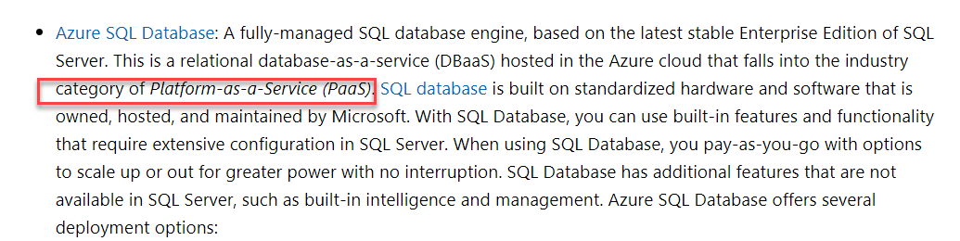

For more information on Azure SQL Databases, please visit the below URL-

<https://docs.microsoft.com/en-us/azure/sql-database/sql-database-paas-vs-sql-server-iaas>

Parte inferior do formulário

Parte superior do formulário

Pergunta 8: **Correto**

A company is planning to use Azure Storage Accounts. They have the following requirement.

* Storage Account should automatically replicate data to the secondary region.

Can configuring the Read-Access Geo-Redundant Storage Account automatically replicate data to the secondary region?

* 

**A. Yes**

**(Correto)**

* 

**B. No**

**Explicação**

**Answer: A**

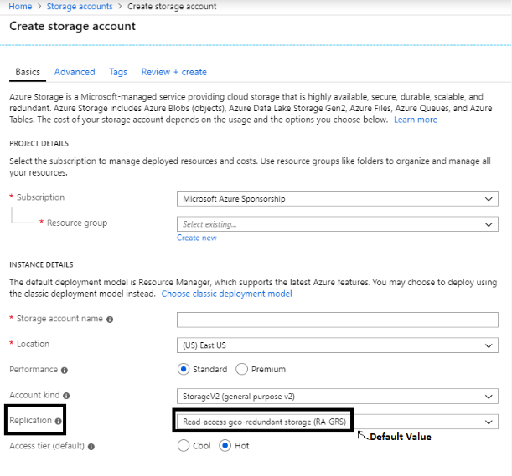

You need to set the replication strategy in order to make this possible. Below is the table on the redundancy for storage accounts.

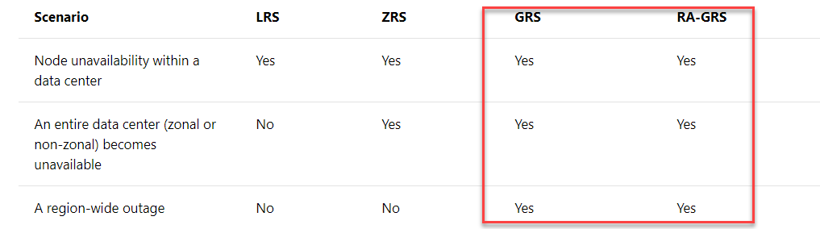

For ensuring data is replicated to another region, you have to choose either Geo-redundant storage or Read access geo-redundant storage.

For more information on Azure storage redundancy, please visit the below URL-

<https://docs.microsoft.com/en-us/azure/storage/common/storage-redundancy>

Parte inferior do formulário

Parte superior do formulário

Pergunta 9: **Incorreto**

A company wants to make use of Azure for the deployment of various solutions. They want to ensure that suspicious attacks and threats to resources in their Azure account are prevented. Which of the following helps prevent such attacks by using built-in sensors in Azure?

* 

**A. Azure AD Identity Protection**

**(Incorreto)**

* 

**B. Azure DDoS attacks**

* 

**C. Azure Privileged Identity Management**

* 

**D. Microsoft Defender for Identity**

**(Correto)**

**Explicação**

**Answer: D**

The Microsoft documentation states the below feature on the Microsoft Defender for Identity service.  
  
Microsoft Defender for Identity is a cloud-based security solution that leverages your on-premises Active Directory signals to identify, detect, and investigate advanced threats, compromised identities, and malicious insider actions directed at your organization.

**Monitor and analyze user behavior and activities**

Defender for Identity's proprietary sensors monitor organizational domain controllers, providing a comprehensive view of all user activities from every device. Defender for Identity monitors and analyzes user activities and information across your network, such as permissions and group membership, creating a behavioral baseline for each user.

**Options A and C are incorrect**since these are used for protecting identities in Azure AD.

**Option B is incorrect** since this is solely a solution to protect against DDoS attacks.

For more information on Azure Advanced Threat Protection, please visit the below URL-

* <https://docs.microsoft.com/en-us/defender-for-identity/what-is>

Parte inferior do formulário

Parte superior do formulário

Pergunta 10: **Incorreto**

You have multiple storage accounts in your subscription. You need to provide read access for storage account1 only to a user, Write access to storage account1 shouldn’t be granted. Access to other storage accounts should not be given.

Which of the following you should configure to achieve this target?

* 

**A. Azure AD Device Management**

* 

**B. Privileged Identity Management(PIM)**

**(Incorreto)**

* 

**C. Azure RBAC**

**(Correto)**

* 

**D. Conditional Access**

**Explicação**

**Answer: C**

* **Option A is Incorrect :**Azure AD Device management helps register our devices to azure. Hence, it can not help in this case.
* **Option B is Incorrect :**Privileged Identity Management (PIM) enables you to manage, control, and monitor access to important resources in your organization. These resources include objects in Azure AD, Azure & M365 only**and not to the Azure storage accounts.**
* **Option C is correct :**Azure RBAC helps us to give fine-grained access control to our users. It can be attached at the resource level also. A reader role at the Storage account1 level will help in this case.
* **Option D is Incorrect :**Conditional Access is simple If-Then statements, which helps you to allow/deny/require MFA to a sign-in attempt based on the signals, not suitable to give access controls.

**Reference:**

* [What is Azure role-based access control (Azure RBAC)? | Microsoft Docs](https://docs.microsoft.com/en-us/azure/role-based-access-control/overview)

Parte inferior do formulário

Parte superior do formulário

Pergunta 11: **Incorreto**

A company has deployed a Virtual Machine in Azure Portal and that Virtual machine named as demovm. The overview of the Virtual Machine is shown below.

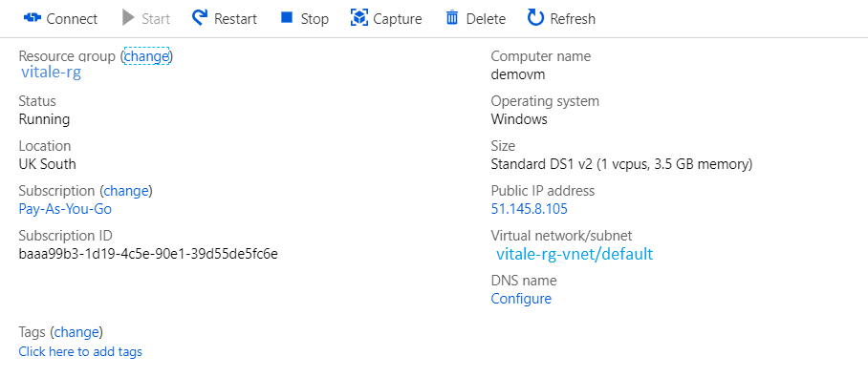

To fix an ongoing problem for the underlying infrastructure hosted in azure, which blade (user interface) do they need to use to help get more information?

* 

**A. Azure Advisor**

**(Incorreto)**

* 

**B. Azure AD**

* 

**C. The Virtual Machine blade**

**(Correto)**

* 

**D. Azure Marketplace**

**Explicação**

**Answer: C**

You can see for any service health issues for the Virtual Machine's infrastructure in the VM blade itself. Just go to Resource health, as shown below.

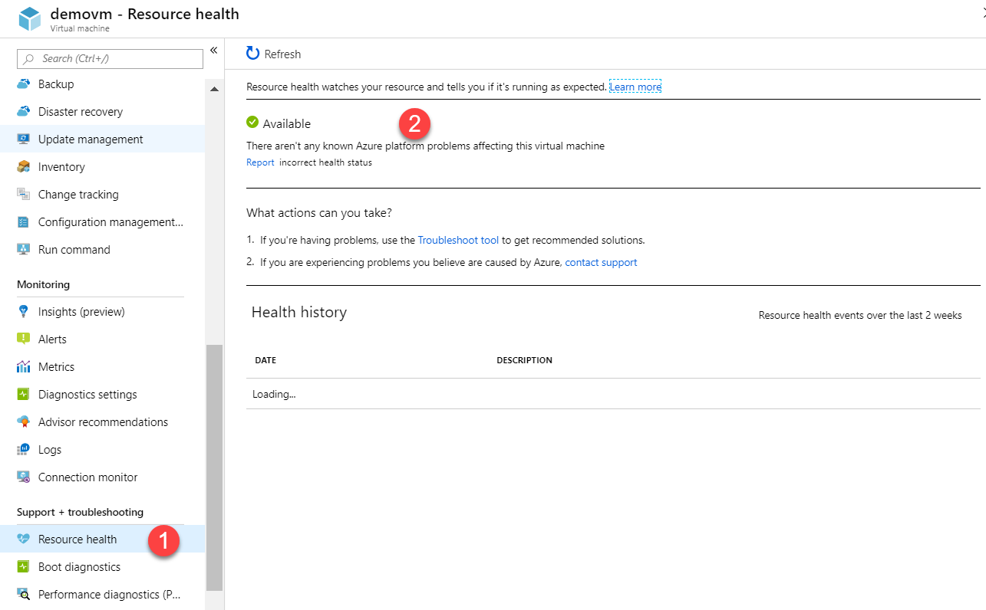

**Option A is incorrect** since this is used to provide recommendations in Azure.

**Option B is incorrect** since this is used for identity management.

**Option D is incorrect** since this is used for buying and selling third-party software and solutions.

For more information on Azure resource health, please visit the below URL-

<https://docs.microsoft.com/en-us/azure/service-health/resource-health-overview>

Parte inferior do formulário

Parte superior do formulário

Pergunta 12: **Incorreto**

A company is planning to host 2 Virtual Machines in Azure, as shown below.

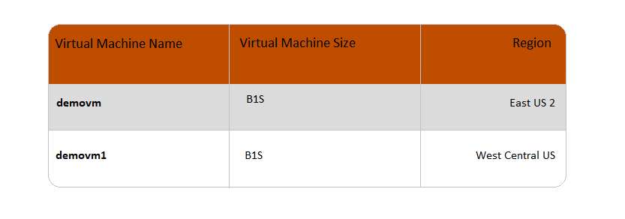

**Would both the Virtual Machines always generate the same monthly costs?**

* 

**A. Yes**

**(Incorreto)**

* 

**B. No**

**(Correto)**

**Explicação**

**Answer: B**

The cost for a Virtual Machine depends on the region where it is hosted.

Below is a screenshot from the link given below where the pricing for a Virtual Machine changes as the region value changes.

<https://azure.microsoft.com/en-in/pricing/details/virtual-machines/windows/>

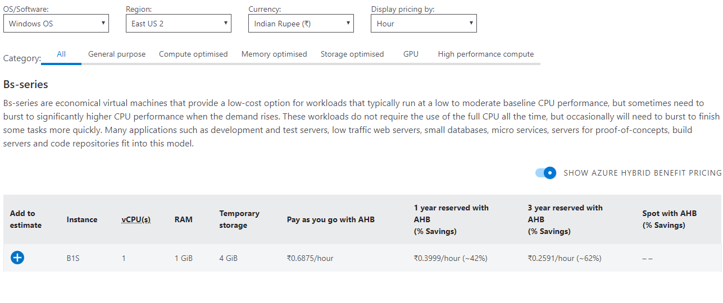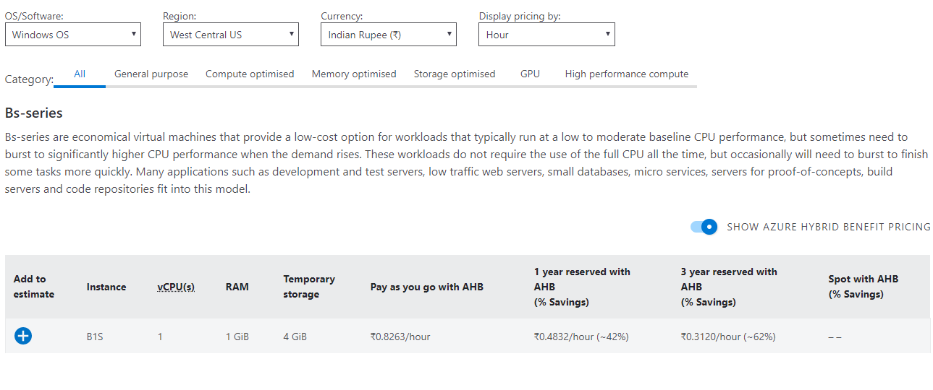

For more information on the pricing calculator, please visit the below URL-

<https://azure.microsoft.com/en-us/pricing/calculator/>

Parte inferior do formulário

Parte superior do formulário

Pergunta 13: **Incorreto**

A company has a set of resources deployed to Azure. They want to make use of the Azure Advisor tool. Would the Azure Advisor tool give recommendations on the tenancy?

* 

**A. Yes**

**(Incorreto)**

* 

**B. No**

**(Correto)**

**Explicação**

**Answer: B**

If you see the Azure Advisor as shown below, the main area recommendations are **Cost, Security, Reliability, Operational excellence & Performance.**

For more information on Azure Advisor, please visit the below URL-

<https://docs.microsoft.com/en-us/azure/advisor/advisor-overview>

Parte inferior do formulário

Parte superior do formulário

Pergunta 14: **Incorreto**

A company is planning to deploy resources to Azure. Which of the following in Azure provides a platform for defining the dependencies between resources so they're deployed in the correct order?

* 

**A. Azure Resource Groups**

* 

**B. Azure policies**

* 

**C. Azure Management Groups**

**(Incorreto)**

* 

**D. Azure Resource Manager**

**(Correto)**

**Explicação**

**Answer: D**

The Microsoft documentation mentions the following.

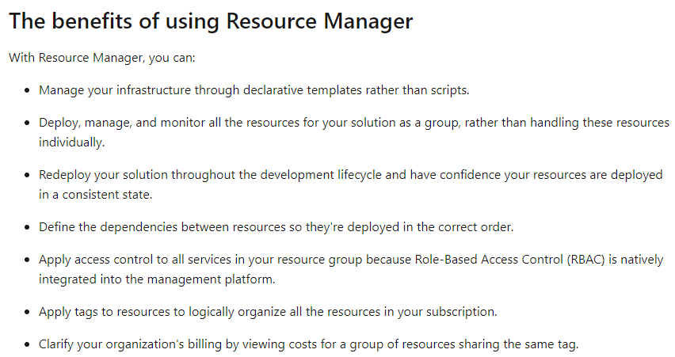

**Option A is incorrect** since this provides a means to categorize resources deployed to Azure. It's not a platform.

**Option B is incorrect** since this allows you to govern Azure resources.

**Option C is incorrect** since this allows you to efficiently manage access, policies, and compliance for those subscriptions.

For more information on Azure Resource Manager, please visit the below URL-

<https://docs.microsoft.com/en-us/azure/azure-resource-manager/resource-group-overview>

Parte inferior do formulário

Parte superior do formulário

Pergunta 15: **Incorreto**

Your organization published a custom web application. You want to use Azure Active Directory as an Identity and access management service provider to authenticate end users to your web applications. By configuring this, which of the following Azure AD features are you using?

* 

**A. Azure AD Tenant**

* 

**B. Azure AD Connect**

**(Incorreto)**

* 

**C. Azure B2B**

* 

**D. Azure B2C**

**(Correto)**

**Explicação**

**Answer: D**

This question describes that you want your customers to be able to use your web application after getting authenticated from the Azure Active Directory.

* **Option A is Incorrect :**Azure AD tenant is a container for Azure AD Objects like users, groups & devices
* **Option B is Incorrect :**Azure AD connect is used to connect On-prem AD to Azure AD
* **Option C is Incorrect :** Azure B2B is used to invite external Azure AD users to your Azure AD. It helps your company to start collaborating with other organizations.
* **Option D is Correct :**Azure AD B2C is used when you use Azure AD to authenticate and authorize end users to your application.

**Reference:**

* [What is Azure Active Directory B2C? | Microsoft Docs](https://docs.microsoft.com/en-us/azure/active-directory-b2c/overview)

Parte inferior do formulário

Parte superior do formulário

Pergunta 16: **Incorreto**

Which of the following option is True regarding Azure File Sync?

* 

**A. Upload/Download files using a physical device**

* 

**B. Copy blobs or files to or from your storage account using the command line**

* 

**C. Download/upload files and blobs in your Azure Storage Account using a GUI-based app installed on your local computer**

**(Incorreto)**

* 

**D. Cloud Tiering - most frequently accessed files are replicated locally, while infrequently accessed files are stored in azure**

**(Correto)**

**Explicação**

**Answer: D**

Azure File Sync is used with a windows server to access your data locally. It uses SMB, NFS, and FTPS protocols

* **Option A is Incorrect:**Azure File sync is not a physical data transfer tool.
* **Option B is Incorrect:**AzCopy is a command line utility used to upload and download files to and from your azure storage account using your command line. In Azure File sync there is no command to upload/download files.
* **Option C is Incorrect:**Azure Storage Explorer is a GUI-based file transfer utility. Azure File Sync has a GUI ONLY TO REGISTER THE WINDOWS SERVER, but it does not uses any GUI to upload / download blobs.
* **Option D is correct:** Azure File Sync helps us to configure cloud tiering so the most frequently accessed files are replicated locally, while infrequently accessed files are kept in the cloud until requested.

**Reference:**

* [Identify Azure file movement options - Learn | Microsoft Docs](https://docs.microsoft.com/en-us/learn/modules/describe-azure-storage-services/7-identify-azure-file-movement-options)

Parte inferior do formulário

Parte superior do formulário

Pergunta 17: **Incorreto**

Your company decides to implement passwordless authentication for an efficient user experience. Being an administrator please identify which of the following passwordless authentication options DOES NOT INTEGRATE with Azure Active Directory (Azure AD).

* 

**A.**

**Windows Hello for Business**

* 

**B.**

**Microsoft Authenticator app**

**(Incorreto)**

* 

**C.**

**FIDO2 security keys**

* 

**D.**

**A cryptographic key**

**(Correto)**

**Explicação**

**Answer: D**

* **Option A is Incorrect**: Windows Hello helps the user to use their biometric and PIN credentials to be inserted into your PC/Laptop which will be used to sign in to the Azure console..
* **Option B is Incorrect:** After installing Microsoft Authenticator App on your phone, users can sign in to any platform or browser by getting a notification on their phone, matching a number displayed on the screen to the one on their phone.
* **Option C is incorrect**: FIDO2 is the latest standard from the FIDO (Fast IDentity Online) Alliance that incorporates the web authentication (WebAuthn) standard. It is a physical component that needs to be attached to your device.
* **Option D is Correct**: Passwordless Authentication does not support cryptographic keys. A cryptographic key is a**string of data that is used to lock or unlock cryptographic functions**, including authentication, authorization, and encryption

**References:**

* [Describe Azure authentication methods - Learn | Microsoft Docs](https://docs.microsoft.com/en-us/learn/modules/describe-azure-identity-access-security/3-authentication-methods)
* [Azure Active Directory passwordless sign-in - Microsoft Entra | Microsoft Docs](https://docs.microsoft.com/en-us/azure/active-directory/authentication/concept-authentication-passwordless)

Parte inferior do formulário

Parte superior do formulário

Pergunta 18: **Incorreto**

A company has several resources hosted in Azure. They want to have a comprehensive solution for collecting, analyzing, and acting on telemetry from the Azure cloud. Which of the following service would you use for this requirement?

* 

**A. Azure Event Hubs**

* 

**B. Azure Analysis Services**

* 

**C. Azure Advisor**

**(Incorreto)**

* 

**D. Azure Monitor**

**(Correto)**

**Explicação**

**Answer: D**

Azure Monitor delivers a comprehensive solution for collecting, analyzing, and acting on telemetry from your cloud and on-premises environments. Thus it maximizes the availability and performance of your applications and services. It helps you understand how your applications are performing and proactively identifies issues affecting them and the resources they depend on.

For more information on Azure Monitor, please visit the below URL-

<https://docs.microsoft.com/en-us/azure/azure-monitor/overview>

You can use Azure Monitor to collect all the data from various sources, as shown below. You can then perform interactive queries on the stored logs.

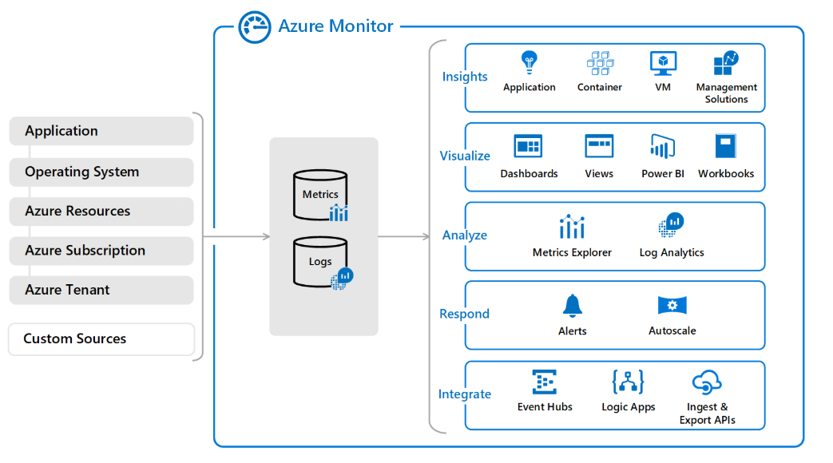

**Option A is incorrect** since this service is a big data streaming platform and event ingestion service.

**Option B is incorrect** since this is a fully managed platform as a service (PaaS) that provides enterprise-grade data models in the cloud.

**Option C is incorrect** since this is used as a recommendation engine.

Parte inferior do formulário

Parte superior do formulário

Pergunta 19: **Incorreto**

A company has a virtual machine called **demovm** in which a web application is installed. This web application should be accessed over the Internet using HTTP. You propose a solution to modify the DDoS Protection plan. Does this solution fit the need?

* 

**A. Yes**

**(Incorreto)**

* 

**B. No**

**(Correto)**

**Explicação**

**Answer: B**

**DDoS Protection** enables you to protect your Azure resources from Distributed denial of service (DDoS) attacks with always-on monitoring and automatic network attack mitigation and not allow the traffic into the Virtual machine.

This would be not the correct service for accessing the web application over the Internet using HTTP.

For more information on DDoS protection, please visit the below URL-

[Azure DDoS Protection Standard Overview | Microsoft Docs](https://docs.microsoft.com/en-us/azure/ddos-protection/ddos-protection-overview)

[Azure DDoS Protection and Mitigation Services | Microsoft Azure](https://azure.microsoft.com/en-us/services/ddos-protection/#overview)

Parte inferior do formulário

Parte superior do formulário

Pergunta 20: **Incorreto**

A company has a virtual machine defined as demovm. This Virtual Machine was created with the standard settings. An application is installed on demovm. It now needs to be ensured that the application can be accessed over the Internet via HTTP using port ranges and prioritized security rules using the 5-tuple information.

You make modifications to the Azure firewall.

Would this solution fit the requirement?

* 

**A. Yes**

**(Correto)**

* 

**B. No**

**(Incorreto)**

**Explicação**

**Answer: A**

You can configure NAT rules, network rules, and **applications rules on Azure Firewall.** Rule collections are processed according to the rule type in priority order, lower numbers to higher numbers from 100 to 65,000. A rule collection name can have only letters, numbers, underscores, periods, or hyphens. It must begin with a letter or number, and end with a letter, number, or underscore. The maximum name length is 80 characters.

It's best to initially space your rule collection priority numbers in 100 increments (100, 200, 300, and so on) so you have room to add more rule collections if needed.  
  
<https://docs.microsoft.com/en-us/azure/firewall/rule-processing>

Parte inferior do formulário

Parte superior do formulário

Pergunta 21: **Incorreto**

A company has a virtual machine defined as demovm. This Virtual Machine was created with the standard settings. An application is installed on demovm. It now needs to be ensured that the application can be accessed over the Internet via HTTP.

You modify the Azure Traffic Manager profile.

Would this solution fit the requirement?

* 

**A. Yes**

**(Incorreto)**

* 

**B. No**

**(Correto)**

**Explicação**

**Answer: B**

The Azure Traffic Manager is a DNS-based traffic load balancer.

For more information on Azure Traffic Manager, please visit the below URL-

<https://docs.microsoft.com/en-us/azure/traffic-manager/traffic-manager-overview>

Parte inferior do formulário

Parte superior do formulário

Pergunta 22: **Correto**

A company has a virtual machine defined as demovm. This Virtual Machine was created with the standard settings. Now this virtual machine needs to communicate with other Azure resources outside the Virtual Network and the VNet peering is already in place.

You modify the Network Security Groups.

Would this solution fit the requirement?

* 

**A. Yes**

**(Correto)**

* 

**B. No**

**Explicação**

**Answer: A**

You should change the Network Security group by adding a rule for allowing Inbound Traffic, as shown below.

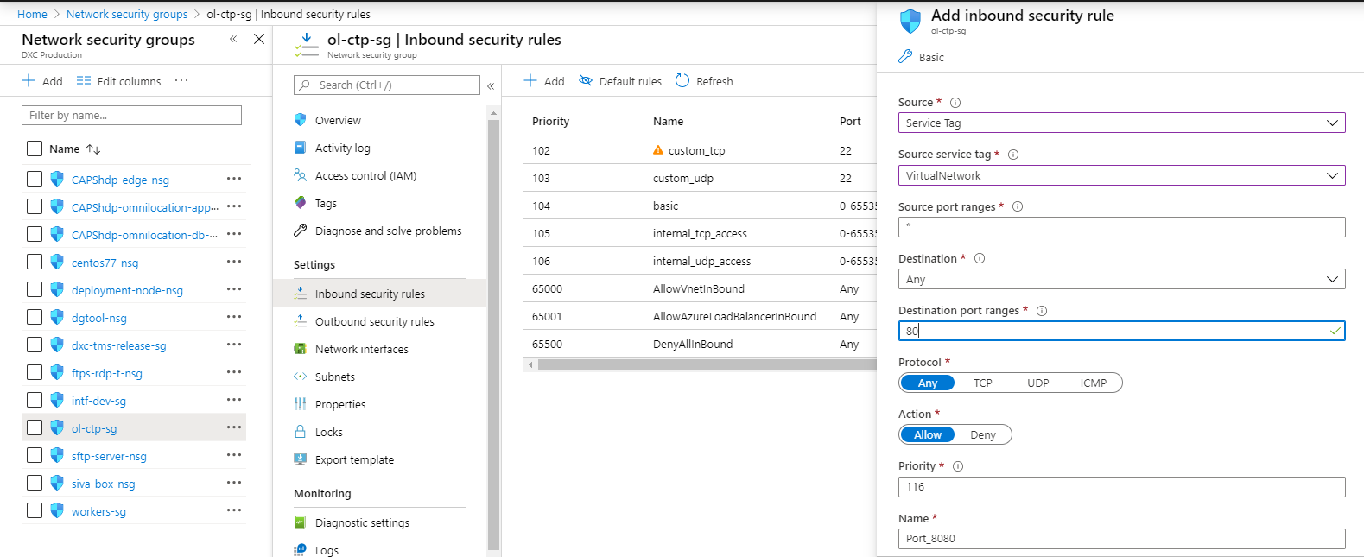

1. Create an Inbound Network Security Rule.
2. Ensure the Service Tag is the Internet.
3. Ensure the destination port range is 80.
4. Ensure the Action is placed as Allow.

For more information on Virtual Network Security, please visit the below URL-

<https://docs.microsoft.com/en-us/azure/virtual-network/security-overview>

Parte inferior do formulário

Parte superior do formulário

Pergunta 23: **Incorreto**

A company plans to purchase an Azure Support plan. Below is a key requirement for the support plan.

* Ensure that for critical business (Severity A) cases, there will be a response within an hour.
* The support Plan should be Low-Price.

A recommendation is made to purchase the Standard Support plan.

Would this recommendation fulfill the requirement?

* 

**A. Yes**

**(Correto)**

* 

**B. No**

**(Incorreto)**

**Explicação**

**Answer: A**

Please find the latest support plans that Azure is providing.

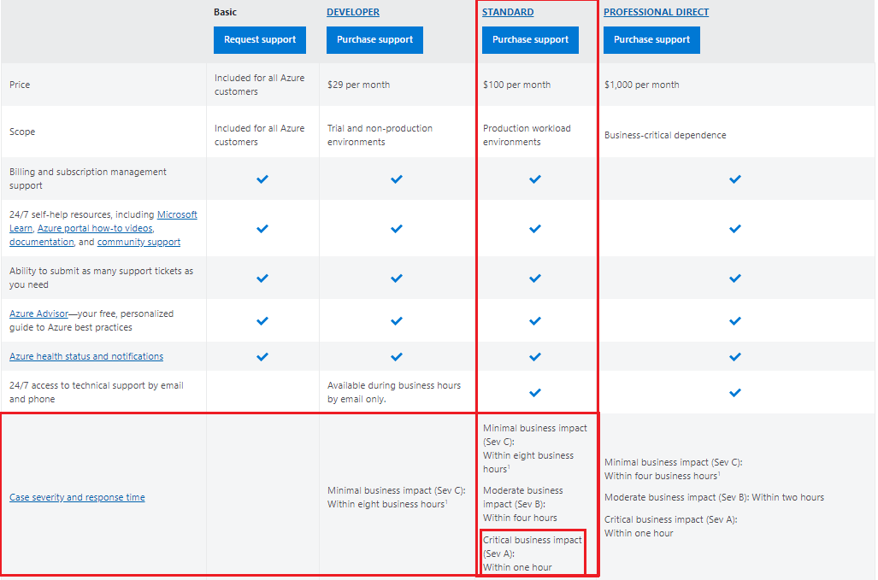

For more information on the support plans, please visit the below URL-

<https://azure.microsoft.com/en-us/support/plans/>

Parte inferior do formulário

Parte superior do formulário

Pergunta 24: **Incorreto**

A company is planning to deploy a web server and database server, as shown in the architecture diagram below. You have to ensure that traffic restrictions are in place so that the database server can only communicate with the web server.

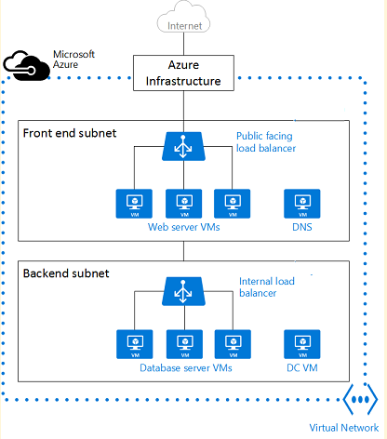

Which of the following would you recommend for implementing these restrictions?

* 

**A. Network Security Groups (NSGs)**

**(Correto)**

* 

**B. Azure Service Bus**

* 

**C. A Local Network Gateway**

**(Incorreto)**

* 

**D. A Virtual Private Gateway**

**Explicação**

**Answer: A**

It would help if you used network security groups to allow or deny traffic within subnets.

Below is what the Microsoft documentation mentions in terms of filtering network traffic.

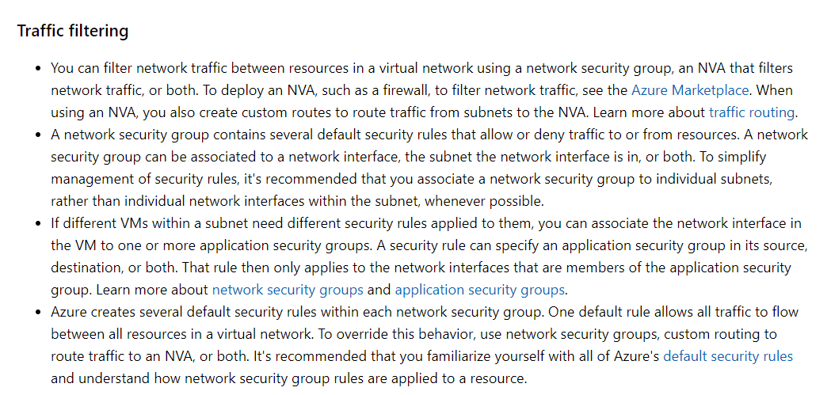

* Option B is incorrect since this is used as a messaging system.
* Option C is incorrect since this is used to represent a VPN device in a Site-to-Site VPN connection.
* Option D is incorrect since this is normally used to connect networks via the Internet.

Remember, Network Security Group (NSG) and Application Security Group (ASG) are two different things. Please visit the below URL to know about ASG-

* <https://docs.microsoft.com/en-us/azure/virtual-network/application-security-groups>

For more information on network planning and design, please visit the below URL-

* <https://docs.microsoft.com/en-us/azure/virtual-network/virtual-network-vnet-plan-design-arm>

Parte inferior do formulário

Parte superior do formulário

Pergunta 25: **Correto**

A company wants to make use of an Azure service in private preview. Are Azure services in private preview available only to a selective portion of customers?

* 

**A. Yes**

**(Correto)**

* 

**B. No**

**Explicação**

**Answer: A**

Services in private preview are only available a few customers to take part in early access to new concepts and features.

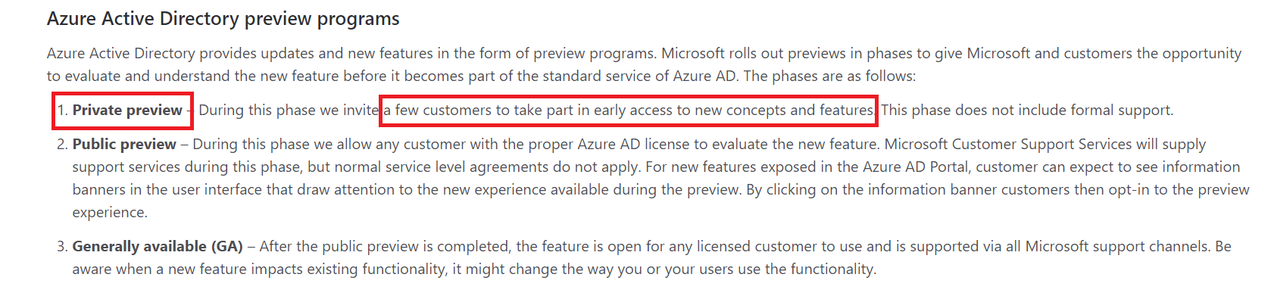

For more information on services in the beta test phase, please visit the below URL-

[Preview Terms Of Use | Microsoft Azure](https://azure.microsoft.com/en-in/support/legal/preview-supplemental-terms/)

Parte inferior do formulário

Parte superior do formulário

Pergunta 26: **Incorreto**

A company wants to make use of an Azure service in public preview. Are Azure services in public preview available to all customers?

* 

**A. Yes**

**(Correto)**

* 

**B. No**

**(Incorreto)**

**Explicação**

**Answer: A**

An example is given below. Here there is a preview available for Virtual Machines in Azure Monitor.

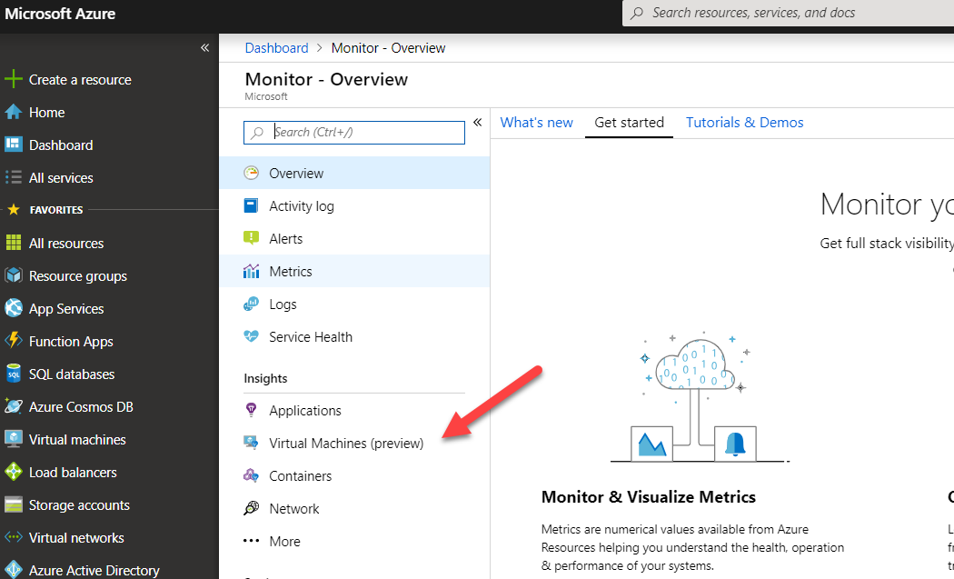

For more information on updates to the Azure platform, please visit the below URL-

<https://azure.microsoft.com/en-us/updates>

Parte inferior do formulário

Parte superior do formulário

Pergunta 27: **Incorreto**

A company is planning to set up an Azure account. Can they purchase multiple Azure subscriptions and associate all subscriptions to a single Azure AD Tenant?

* 

**A. Yes**

**(Correto)**

* 

**B. No**

**(Incorreto)**

**Explicação**

**Answer: A**

Yes, you can have multiple subscriptions against a single AD tenant, as shown below in the Microsoft documentation.

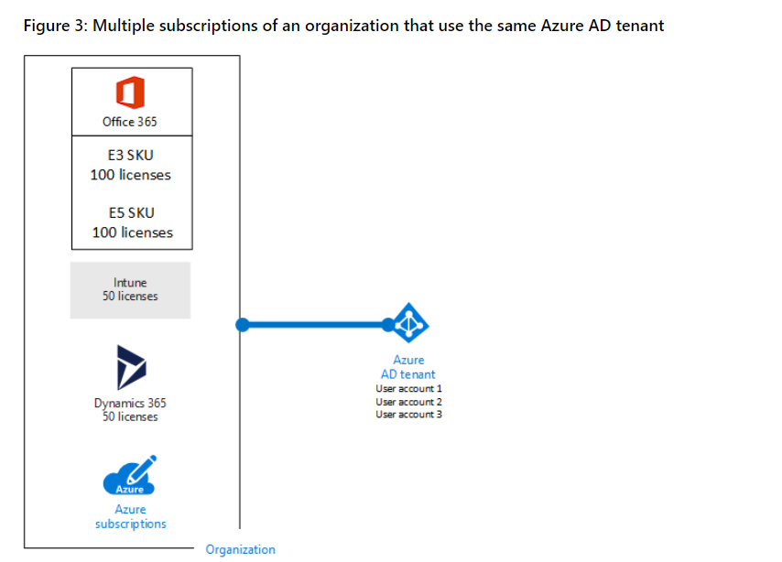

For more information on subscriptions, licenses and tenants please visit the below URL-

* [https://docs.microsoft.com/en-us/office365/enterprise/subscriptions-licenses-accounts-and-tenants-for-microsoft-cloud-offerings](https://docs.microsoft.com/en-us/office365/enterprise/subscriptions-licenses-accounts-and-tenants-for-microsoft-cloud-offerings/)

Parte inferior do formulário

Parte superior do formulário

Pergunta 28: **Correto**

Your company has multiple subscriptions in Azure. The administrators want to transfer billing ownership of the subscriptions to your company's accounts.

Does your administrator need to contact Microsoft for this activity?

* 

**A. Yes**

* 

**B. No**

**(Correto)**

**Explicação**

**Answer: B**

Ideally, you would look to transfer subscriptions under one account and manage them centrally. If you go to your subscription, there will be a Transfer subscription option as shown below.

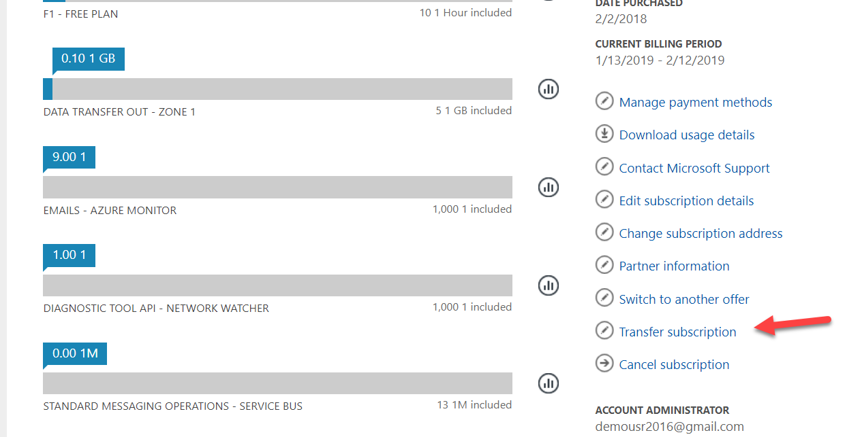

For more information on transferring subscriptions please visit the below URL-

* <https://docs.microsoft.com/en-us/azure/billing/billing-subscription-transfer>

Parte inferior do formulário

Parte superior do formulário

Pergunta 29: **Correto**

A company has multiple subscriptions. They want to create resources in different subscriptions. Is it possible to create the same type of Azure resources in different Azure subscriptions?

* 

**A. Yes**

**(Correto)**

* 

**B. No**

**Explicação**

**Answer: A**

An example of this is given below. Here we have 2 storage accounts created in one Azure account, under multiple subscriptions.

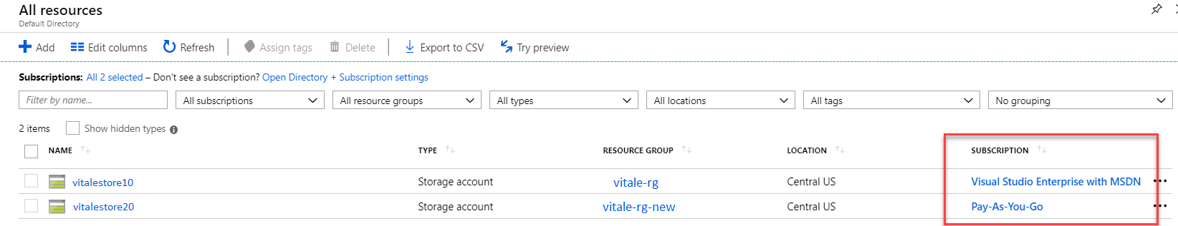

For more information on Azure resource manager, please visit the below URL-

<https://docs.microsoft.com/en-us/azure/azure-resource-manager/resource-group-overview>

Parte inferior do formulário

Parte superior do formulário

Pergunta 30: **Correto**

A company is planning to set up a solution in Azure. The solution would have the following key requirement.

* Provide an analytics service for BI and machine learning needs.

Which of the following would be best suited for this requirement?

* 

**A. Azure Content Delivery Network**

* 

**B. Azure Synapse Analytics**

**(Correto)**

* 

**C. Azure Load Balancer**

* 

**D. Azure Cosmos DB**

**Explicação**

**Answer: B**

The Microsoft documentation mentions the following.

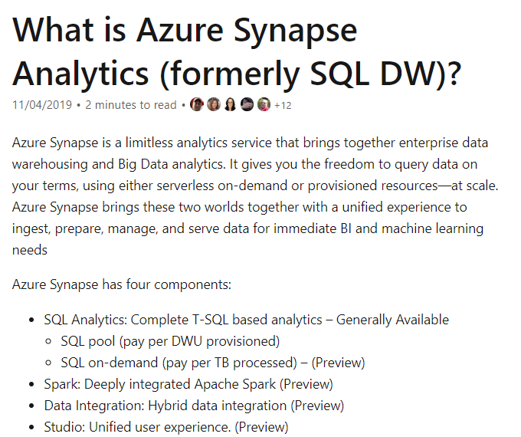

For more information on the Azure Synapse service, please visit the below URL-

* <https://docs.microsoft.com/en-us/azure/sql-data-warehouse/sql-data-warehouse-overview-what-is>

Parte inferior do formulário

Parte superior do formulário

Pergunta 31: **Correto**

A company is planning to set up a solution in Azure. The solution would have the following key requirement.

* Provide an efficient way to distribute web content to users across the world.

Which of the following would be best suited for this requirement?

* 

**A. Azure Content Delivery Network**

**(Correto)**

* 

**B. Azure SQL Datawarehouse**

* 

**C. Azure Load Balancer**

* 

**D. Azure HD Insight**

**Explicação**

**Answer: A**

The Microsoft documentation mentions the following.

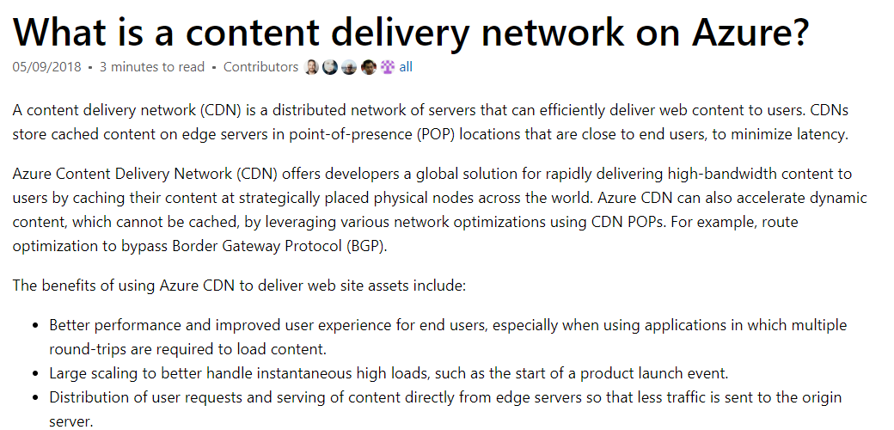

Since this is a clear feature of the tool, all other options are incorrect.

For more information on Azure Content Delivery, please visit the below URL-

<https://docs.microsoft.com/en-us/azure/cdn/cdn-overview>

Parte inferior do formulário

Parte superior do formulário

Pergunta 32: **Incorreto**

A company is planning to set up a solution in Azure. The solution would have the following key requirement.

Provide the ability to distribute user traffic to a set of backend Virtual Machines Which of these features satisfies the requirement?

* 

**A. Azure Content Delivery Network**

**(Incorreto)**

* 

**B. Azure SQL Datawarehouse**

* 

**C. Azure Load Balancer**

**(Correto)**

* 

**D. Azure HD Insight**

**Explicação**

**Answer: C**

The Microsoft documentation mentions the following.

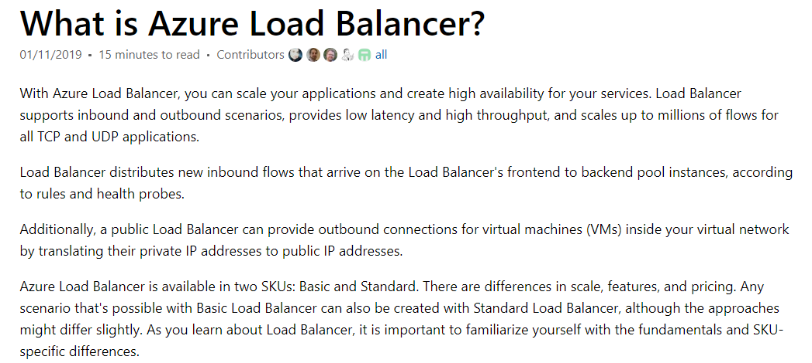

Since this is a clear feature of the tool, all other options are incorrect.

For more information on Azure Load Balancer, please visit the below URL-

<https://docs.microsoft.com/en-us/azure/load-balancer/load-balancer-overview>

Parte inferior do formulário

Parte superior do formulário

Pergunta 33: **Incorreto**

A company is planning to set up a solution in Azure. The solution would have the following key requirement.

Provide a cloud service that makes it easy, fast, and cost-effective to analyze streaming data using open source frameworks like Apache Hadoop.

Which of the following Azure services would meet the criteria?

* 

**A. Azure Content Delivery Network**

**(Incorreto)**

* 

**B. Azure Synapse**

* 

**C. Azure Load Balancer**

* 

**D. Azure HDInsight**

**(Correto)**

**Explicação**

**Answer: D**

The Microsoft documentation mentions the following.

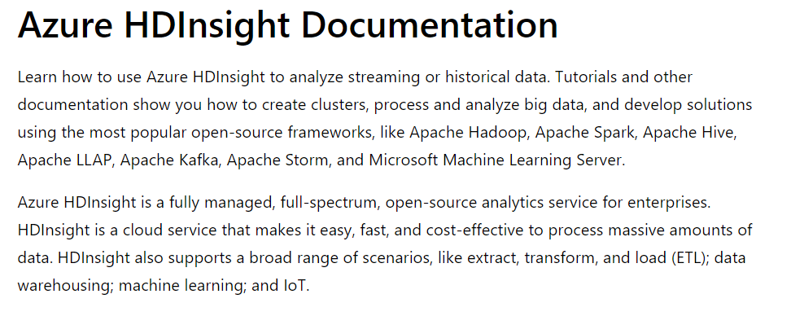

Since this is a clear feature of the tool, all other **options are incorrect**.

For more information on Azure HDInsight, please visit the below URL-

* <https://docs.microsoft.com/en-us/azure/hdinsight/>

Parte inferior do formulário

Parte superior do formulário

Pergunta 34: **Incorreto**

A company is planning to use Azure Cloud for hosting resources. Which of the following is a key advantage of hosting resources in the Azure public cloud?

* 

**A. All users across the world can access the resources in your Azure account.**

* 

**B. High reliability - a vast network of servers ensures against failure**

**(Correto)**

* 

**C. Only privileged users can have access to resources in your Azure account.**

**(Incorreto)**

* 

**D. You pay a capital upfront cost when using resources in the public cloud.**

**Explicação**

**Answer: B**

**What is a public cloud?**

Public clouds are the most common way of deploying cloud computing. The cloud resources (like servers and storage) are owned and operated by a third-party [cloud service provider](https://azure.microsoft.com/en-in/overview/what-is-cloud-computing/) and delivered over the Internet. [Microsoft Azure](https://azure.microsoft.com/en-in/) is an example of a public cloud. With a public cloud, all hardware, software and other supporting infrastructure are owned and managed by the cloud provider. In a public cloud, you share the same hardware, storage and network devices with other organizations or cloud “tenants.” You access services and manage your account using a web browser. Public cloud deployments are frequently used to provide web-based email, online office applications, storage and testing and development environments.

**Advantages of public clouds:**

* Lower costs—no need to purchase hardware or software and you pay only for the service you use.
* No maintenance—your service provider provides the maintenance.
* Near-unlimited scalability—on-demand resources are available to meet your business needs.
* High reliability—a vast network of servers ensures against failure.
* Reference URL-
  + <https://azure.microsoft.com/en-in/overview/what-are-private-public-hybrid-clouds/>

Parte inferior do formulário

Parte superior do formulário

Pergunta 35: **Correto**

A company needs to deploy several identical virtual machines. Each of these virtual machines will have the same set of permissions. To minimize the administrative overhead, where would you deploy the Azure Virtual Machines?

* 

**A. Azure policies**

* 

**B. Azure Virtual Machine Scale sets**

* 

**C. Azure Resource Groups**

**(Correto)**

* 

**D. Azure Tags**

**Explicação**

**Answer: C**

When you deploy a resource to a resource group with a set of permissions defined, the resource will inherit the permissions assigned to the resource group. An example is shown below.

1. An example is shown below where a resource group has a permission defined.

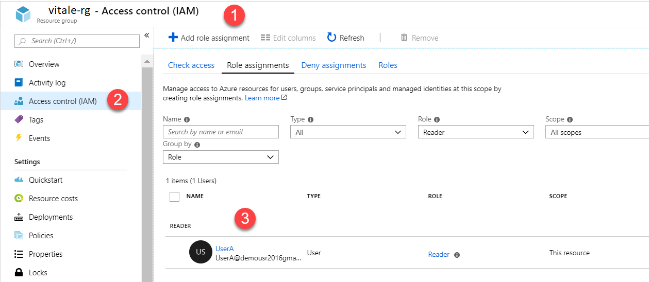

1. And there is a resource defined in the resource group.

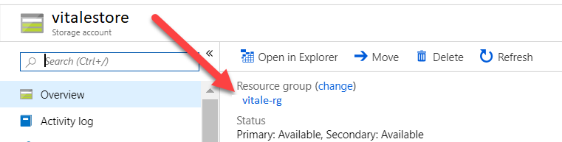

1. If you go to the Access Control section of the resource, you will see that the permissions are inherited from the resource group.

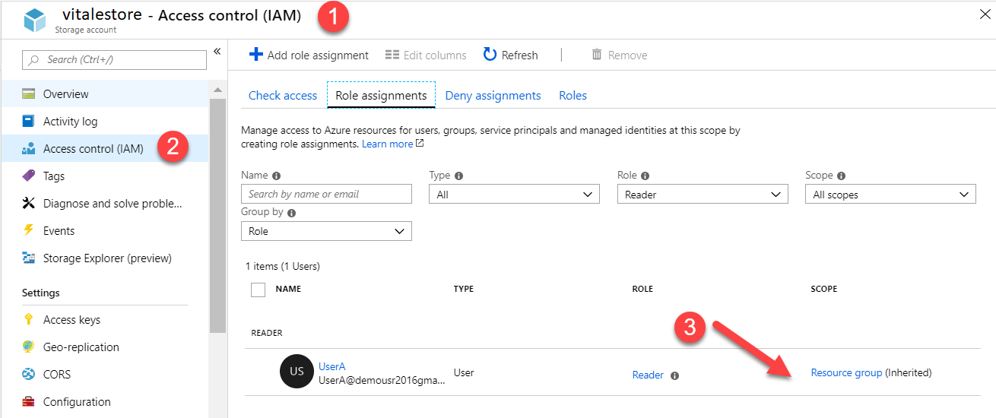

For more information on role-based access control, please visit the below URL-

* + <https://docs.microsoft.com/en-us/azure/role-based-access-control/role-assignments-portal>

Parte inferior do formulário

Parte superior do formulário

Pergunta 36: **Correto**

An application consists of a set of virtual machines hosted in a Virtual Network. In a month, the application seems to have a load of around 20% for 3 weeks. During the last week, the load on the application reaches 80%. Which of the following benefits of Azure Cloud would ensure the underlying application infrastructure's cost and efficiency?

* 

**A. High availability**

* 

**B. Elasticity**

**(Correto)**

* 

**C. Disaster recovery**

* 

**D. Fault tolerance**

**Explicação**

**Answer: B**

Here the concept refers to Elasticity.

* In this use case, you could define a Virtual Machine Scale set in Azure.
* You could define an initial set of Virtual Machines as part of the scale set that would run for the first 3 weeks.
* You can then add a scaling policy to add more Virtual Machines to support the application during the last week.
* You can then add a scaling policy to remove the extra Virtual Machines at the end of last week to save on costs.

All other options are incorrect since they all refer to the availability of the infrastructure.

For more information on Virtual Machine scale sets, please visit the below URL-

<https://docs.microsoft.com/en-us/azure/virtual-machine-scale-sets/overview>

Parte inferior do formulário

Parte superior do formulário

Pergunta 37: **Incorreto**

A company wants to start using Azure. They want to use availability zones in Azure. Which of the following is attached to the concept of availability zones in Azure?

* 

**A. Region failure**

**(Incorreto)**

* 

**B. Resource failure**

* 

**C. Data Center failure**

**(Correto)**

* 

**D. Azure failure**

**Explicação**

**Answer: C**

The Microsoft documentation mentions the following.

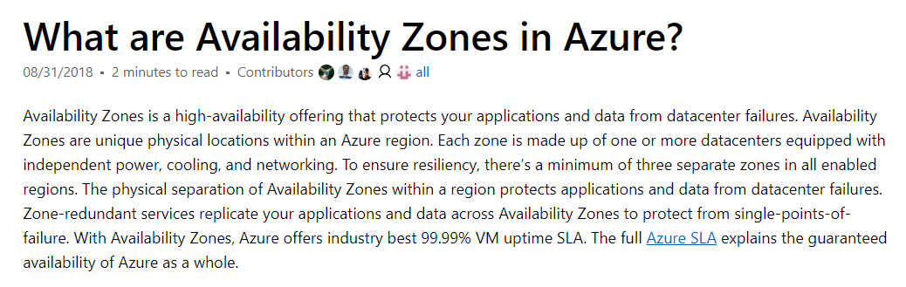

Since this is clearly mentioned in the Microsoft documentation, all other options are incorrect.

For more information on availability zones, please visit the below URL-

<https://docs.microsoft.com/en-us/azure/availability-zones/az-overview>

Parte inferior do formulário

Parte superior do formulário

Pergunta 38: **Incorreto**

A company wants to start using Azure with availability zones. If they have resources deployed across all regions in Azure, can they implement availability zones in all regions?

* 

**A. Yes**

**(Incorreto)**

* 

**B. No**

**(Correto)**

**Explicação**

**Answer: B**

Currently, availability zones are not available in all regions. You need to check first on the availability of zones in a region.

Below is the snapshot from the Microsoft documentation.

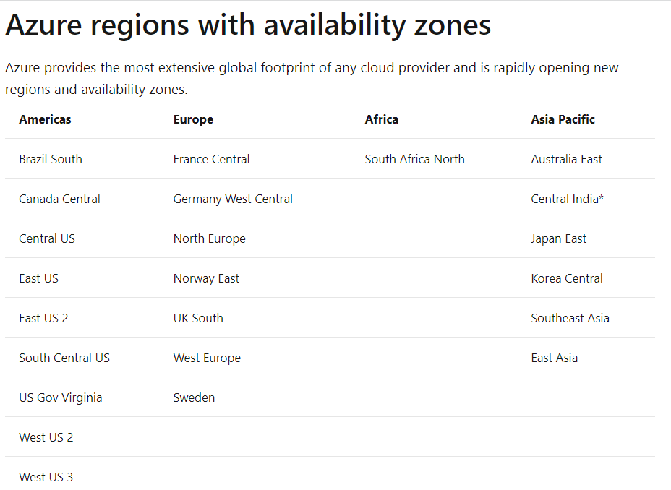

For more information on availability zones, please visit the below URL-

* <https://docs.microsoft.com/en-us/azure/availability-zones/az-overview>

Parte inferior do formulário

Parte superior do formulário

Pergunta 39: **Incorreto**

A company is planning to create resources for different departments in Azure. They want to ensure that they get the bills based on different departments. Which of the following should you consider implementing for this requirement?

* 

**A. Azure locks**

* 

**B. Azure tags**

**(Correto)**

* 

**C. Azure Monitor**

**(Incorreto)**

* 

**D. Azure Advisor**

**Explicação**

**Answer: B**

The Microsoft documentation mentions the following.

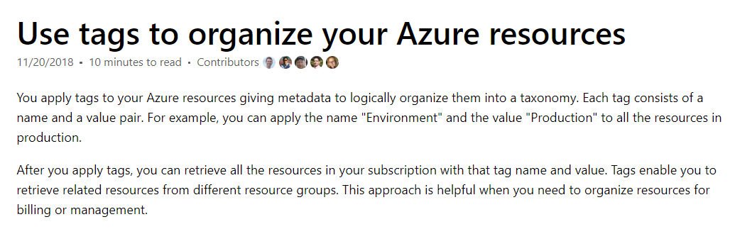

An example is given below. Below is a resource being tagged. A department name and value are used as the tag.

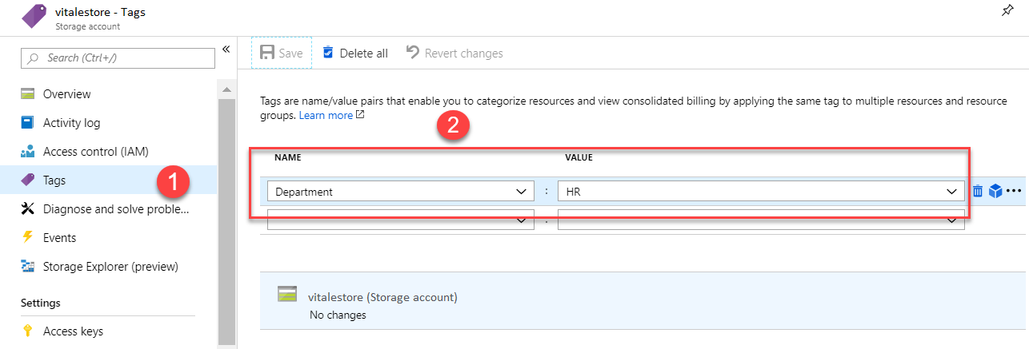

Then in cost analysis, you can segregate costs based on tags.

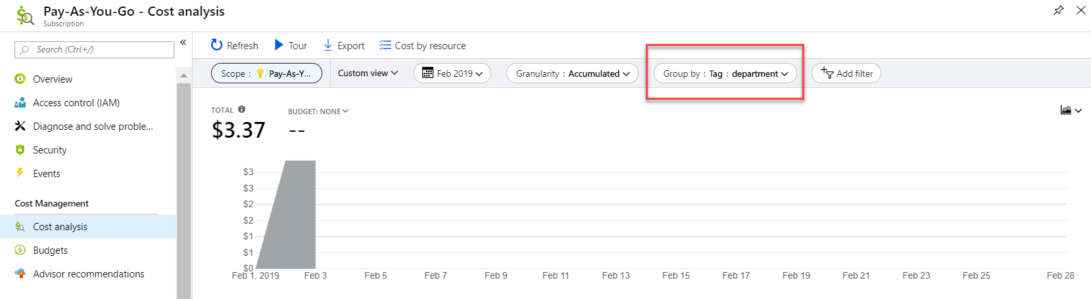

For better understanding please refer to the below reference link.

<https://docs.microsoft.com/en-us/azure/azure-resource-manager/resource-group-using-tags>  
  
**Option A is incorrect** since this is used to ensure that resources don’t get accidentally deleted.

**Option C is incorrect**since this is used to monitor resources.

**Option D is incorrect** since this is used for providing recommendations in Azure.

For more information on using tags, please visit the below URL-<https://docs.microsoft.com/en-us/azure/azure-resource-manager/resource-group-using-tags>

Parte inferior do formulário

Parte superior do formulário

Pergunta 40: **Incorreto**

A company needs to create a set of resources in Azure. They have a requirement that IT Administrators must create resources only in a certain region. Which of the following can help achieve this?

* 

**A. Azure Tags**

**(Incorreto)**

* 

**B. Azure Policies**

**(Correto)**

* 

**C. Azure Resource Groups**

* 

**D. Azure Locks**

**Explicação**

**Answer: B**

You can use Azure policy for the governance of your resources. An example policy on this line is shown below.

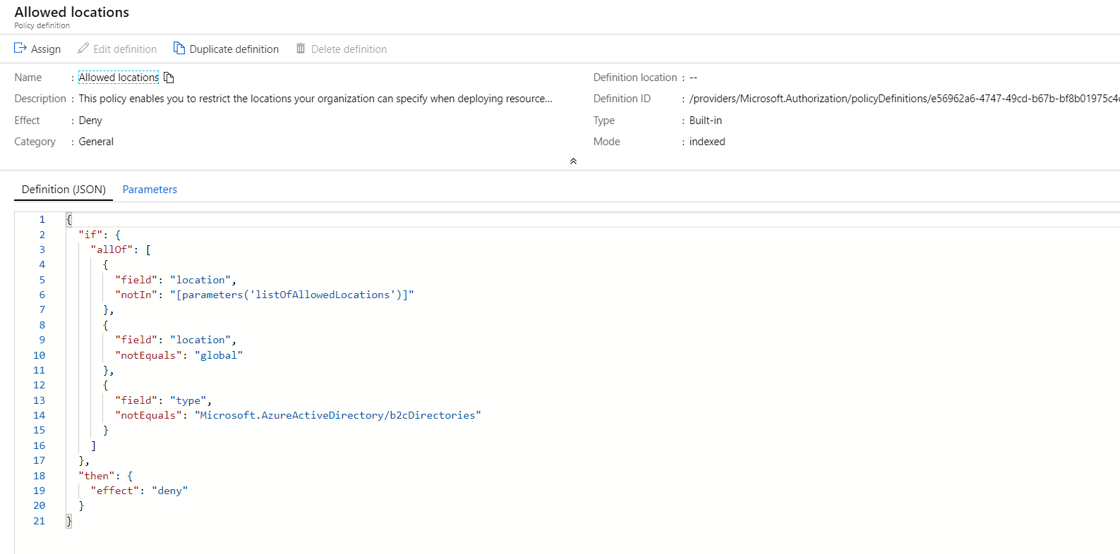

Option A is incorrect since this is used for management and billing purpose.

Option C is incorrect since this is used to group resources.

Option D is incorrect since this is used to ensure that resources don’t get accidentally deleted.

For more information on Azure policies, please visit the below URL-

<https://docs.microsoft.com/en-us/azure/governance/policy/overview>

Parte inferior do formulário

Parte superior do formulário

Pergunta 41: **Incorreto**

Under which of the following cloud computing models would the Azure "Content Delivery" service fall into?

* 

**A. Infrastructure as a service (IaaS)**

* 

**B. Platform as a service (PaaS)**

**(Correto)**

* 

**C. Software as a service (SaaS)**

**(Incorreto)**

* 

**D. Function as a service (FaaS)**

**Explicação**

**Answer: B**

The Platform for hosting Azure CDN is managed completely by Azure. Below is the description of the service from the Microsoft documentation.

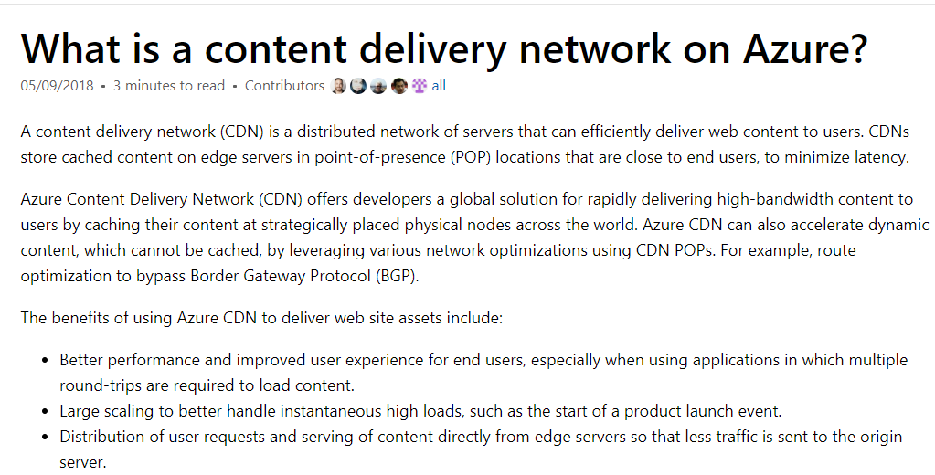

Storage is very important in Azure. Without storage then Azure would not exist. There are several different aspects of storage that we need to understand. We look at each of these different concepts. Things like the storage account, replication, lift/shift and so much more.

Azure Content Delivery Network (CDN) is a global CDN solution for delivering high-bandwidth content. With Azure CDN, you can cache static objects loaded from Azure Blob storage, a web application, or any publicly accessible web server,by using the closest point of presence (POP) server.

A content delivery network (CDN) is a distributed network of servers that can efficiently deliver web content to users. CDNs store cached content on edge servers in point-of-presence (POP) locations that are close to end-users, to minimize latency.

Azure Content Delivery Network (CDN) offers developers a global solution for rapidly delivering high-bandwidth content to users by caching their content at strategically placed physical nodes across the world. Azure CDN can also accelerate dynamic content, which cannot be cached, by leveraging various network optimizations using CDN POPs. For example, route optimization to bypass Border Gateway Protocol (BGP).

The benefits of using Azure CDN to deliver website assets include:

* Better performance and improved user experience for end-users, especially when using applications in which multiple round-trips are required to load content.
* Large scaling to better handle instantaneous high loads, such as the start of a product launch event.
* Distribution of user requests and serving of content directly from edge servers so that less traffic is sent to the origin server.

Please refer to the below video for your reference.

[**https://www.coursera.org/lecture/azure-infrastructure/cdn-content-delivery-network-bplZU**](https://www.coursera.org/lecture/azure-infrastructure/cdn-content-delivery-network-bplZU)

Since this is the right category for the service, all other options are incorrect.

* For more information on the Azure CDN service, please visit the below URL-
  + <https://docs.microsoft.com/en-us/azure/cdn/cdn-overview>
  + <https://azure.microsoft.com/en-in/blog/enable-azure-cdn-directly-from-azure-cloud-services-portal-extension/>

Parte inferior do formulário

Parte superior do formulário

Pergunta 42: **Correto**

A company wants to host an application in Azure. The application connects to a database in Azure. The company would like to store the database password in a secure location.

You recommend the usage of the Azure key vault for the storage of the password.

Would this fulfill the requirement?

* 

**A. Yes**

**(Correto)**

* 

**B. No**

**Explicação**

**Answer: A**

Yes, this is the right tool to use. Below is what the Microsoft documentation states about this service.

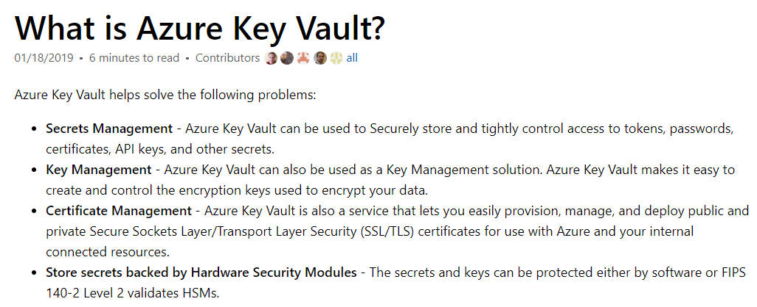

For more information on the Azure Key vault, please visit the below URL-

* <https://docs.microsoft.com/en-us/azure/key-vault/key-vault-whatis>

Parte inferior do formulário

Parte superior do formulário

Pergunta 43: **Correto**

A company wants to host an application in Azure. The application connects to a database in Azure. The company wants to store the database password in a secure location.

You recommend the usage of the Azure Security Center for the storage of the password.

Would this fulfill the requirement?

* 

**A. Yes**

* 

**B. No**

**(Correto)**

**Explicação**

**Answer: B**

This is used more of a protective layer for your resources in Azure. Below is what the Microsoft documentation states about this service.

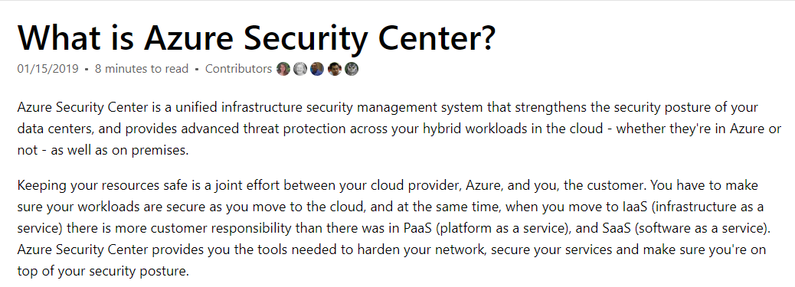

For more information on the Azure Security Service, please visit the below URL-

<https://docs.microsoft.com/en-us/azure/security-center/security-center-intro>

Parte inferior do formulário

Parte superior do formulário

Pergunta 44: **Correto**

A company wants to host an application in Azure. The application connects to a database in Azure. The company wants to store the database password in a secure location.

You recommend the usage of the Azure Advisor for the storage of the password.

Would this fulfill the requirement?

* 

**A. Yes**

* 

**B. No**

**(Correto)**

**Explicação**

**Answer: B**

This is a recommendation tool. Below is what the Microsoft documentation states about this service.

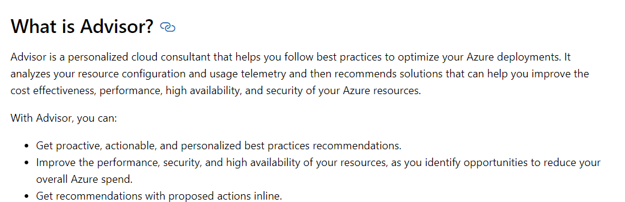

For more information on the Azure Advisor, please visit the below URL-

* <https://docs.microsoft.com/en-us/azure/advisor/advisor-overview>

Parte inferior do formulário

Parte superior do formulário

Pergunta 45: **Correto**

A company needs to connect its on-premises data center to an Azure Virtual Network using a Site-to-Site connection. Which of the following would you create as part of this implementation?

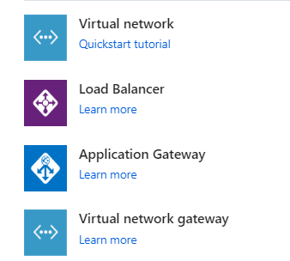

* 

**A. Virtual Network**

* 

**B. Load Balancer**

* 

**C. Application Gateway**

* 

**D. Virtual Network Gateway**

**(Correto)**

**Explicação**

**Answer: D**

The Microsoft documentation mentions the following.

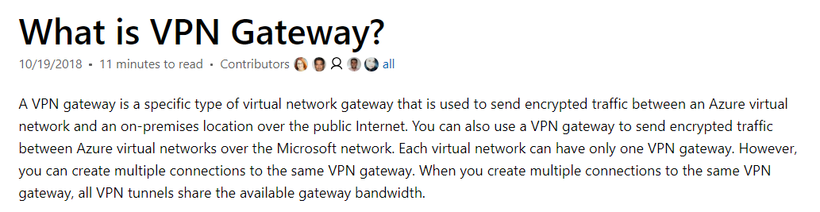

Option A is incorrect since this is used to create a network in Azure.

Options B and C are incorrect since this is used to divert traffic to backend Virtual Machines.

For more information on the Virtual Private gateway, please visit the below URL-

* <https://docs.microsoft.com/en-us/azure/vpn-gateway/vpn-gateway-about-vpngateways>

Parte inferior do formulário

Parte superior do formulário

Pergunta 46: **Incorreto**

A company is planning to set up a private cloud network. Which of the following is an advantage of setting up a private cloud network?

* 

**A. A Private Cloud environment can only support an Infrastructure as a service model.**

**(Incorreto)**

* 

**B. A Private Cloud environment can only support a Platform as a service model.**

* 

**C. The Private Cloud environment can be rolled out to the general public.**

* 

**D. The Private Cloud environment has a higher level of security and privacy.**

**(Correto)**

**Explicação**

**Answer: D**

The Microsoft documentation mentions the following.

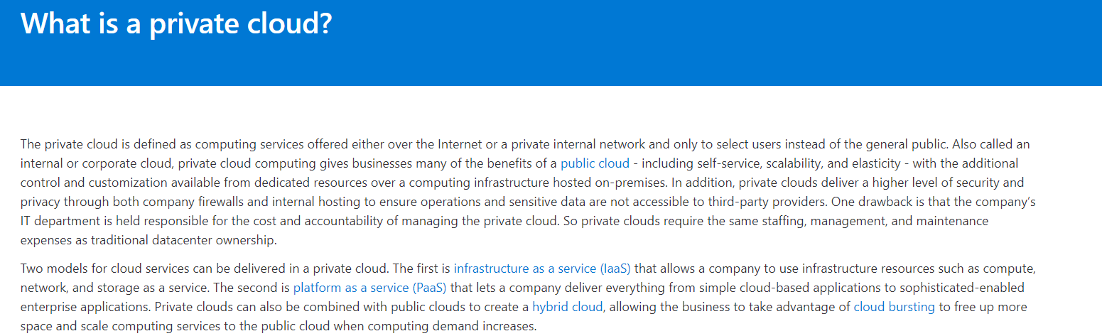

Since this is clearly mentioned, all other options are incorrect.

For more information on the private cloud network, please visit the below URL-

<https://azure.microsoft.com/en-us/overview/what-is-a-private-cloud/>

Parte inferior do formulário

Parte superior do formulário

Pergunta 47: **Correto**

A company wants to set up resources in Azure. They want a way to manage identities in Azure. Which of the following is used as an Identity Management solution in Azure?

* 

**A. Azure AD**

**(Correto)**

* 

**B. Azure Advisor**

* 

**C. Azure Security Center**

* 

**D. Azure Monitor**

**Explicação**

**Answer: A**

The Microsoft documentation mentions the following.

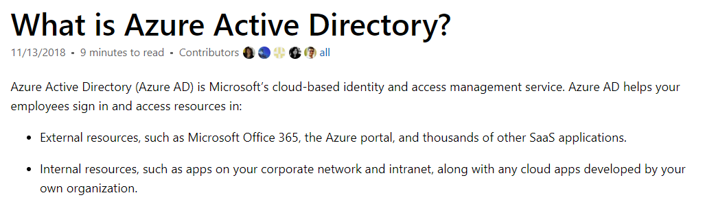

Option B is incorrect since this is used to provide recommendations.

Option C is incorrect since this is used to protect resources in Azure.

Option D is incorrect since this is used to monitor resources in Azure.

For more information on Azure AD, please visit the below URL-

<https://docs.microsoft.com/en-us/azure/active-directory/fundamentals/active-directory-whatis>

Parte inferior do formulário

Parte superior do formulário

Pergunta 48: **Incorreto**

A company is planning to set up a database on Azure SQL database service. Would the company administrative team have full control over the underlying server hosting the Azure SQL database?

* 

**A. Yes**

**(Incorreto)**

* 

**B. No**

**(Correto)**

**Explicação**

**Answer: B**

The Azure SQL database service is a Platform as a service. Here the underlying infrastructure is completely managed by Azure.

The Microsoft documentation mentions the following.

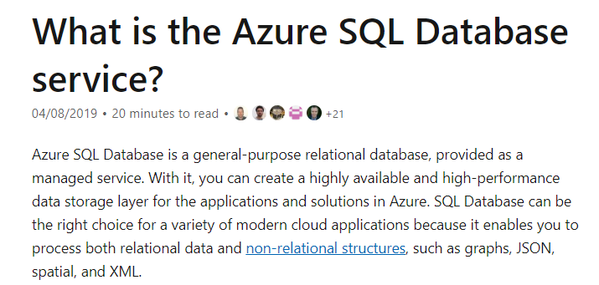

For more information on the Azure SQL database, please visit the below URL-

<https://docs.microsoft.com/en-us/azure/sql-database/sql-database-technical-overview>

Parte inferior do formulário

Parte superior do formulário

Pergunta 49: **Incorreto**

A company has a virtual machine called **demovm** in which a web application is installed. This web application should be accessed over the Internet using HTTP. You propose a solution to modify the DDoS Protection plan. Does this solution fit the need?

* 

**A. Yes**

**(Incorreto)**

* 

**B. No**

**(Correto)**

**Explicação**

**Answer: B**

**DDoS Protection** enables you to protect your Azure resources from Distributed denial of service (DDoS) attacks with always-on monitoring and automatic network attack mitigation and not allow the traffic into the Virtual machine.

This would be not the correct service for accessing the web application over the Internet using HTTP.

For more information on DDoS protection, please visit the below URL-

[Azure DDoS Protection Standard Overview | Microsoft Docs](https://docs.microsoft.com/en-us/azure/ddos-protection/ddos-protection-overview)

[Azure DDoS Protection and Mitigation Services | Microsoft Azure](https://azure.microsoft.com/en-us/services/ddos-protection/#overview)

Parte inferior do formulário

Parte superior do formulário

Pergunta 50: **Incorreto**

Your company is trying to assess the benefits of using the Azure Cosmos DB service. Can they migrate their existing MongoDB database onto Azure Cosmos DB?

* 

**A. Yes**

**(Correto)**

* 

**B. No**

**(Incorreto)**

**Explicação**

**Answer: A**

There are multiple API’s available with Azure Cosmos DB. One of the API’s that can be used is the MongoDB API. You can migrate your existing MongoDB workloads to Azure Cosmos DB as well.

For more information on Azure Cosmos DB- MongoDB API, please visit the below URL

* <https://docs.microsoft.com/en-us/azure/cosmos-db/mongodb-introduction>

Parte inferior do formulário